

Cloud Computing Assignment #2 Spring 2018

Sri Devi Mallipudi

16251191

**Task: Prepare a simple web page (html file) with your name on it. Use any tools or even just MS-word and save it as a html file and deploy the web page on 1) Google Cloud Platform, 2) MS Azure, and 3) Amazon AWS**

**Deploying web page on Google Cloud Platform:**

1. Go to URL <https://cloud.google.com/>and login with your google credentials

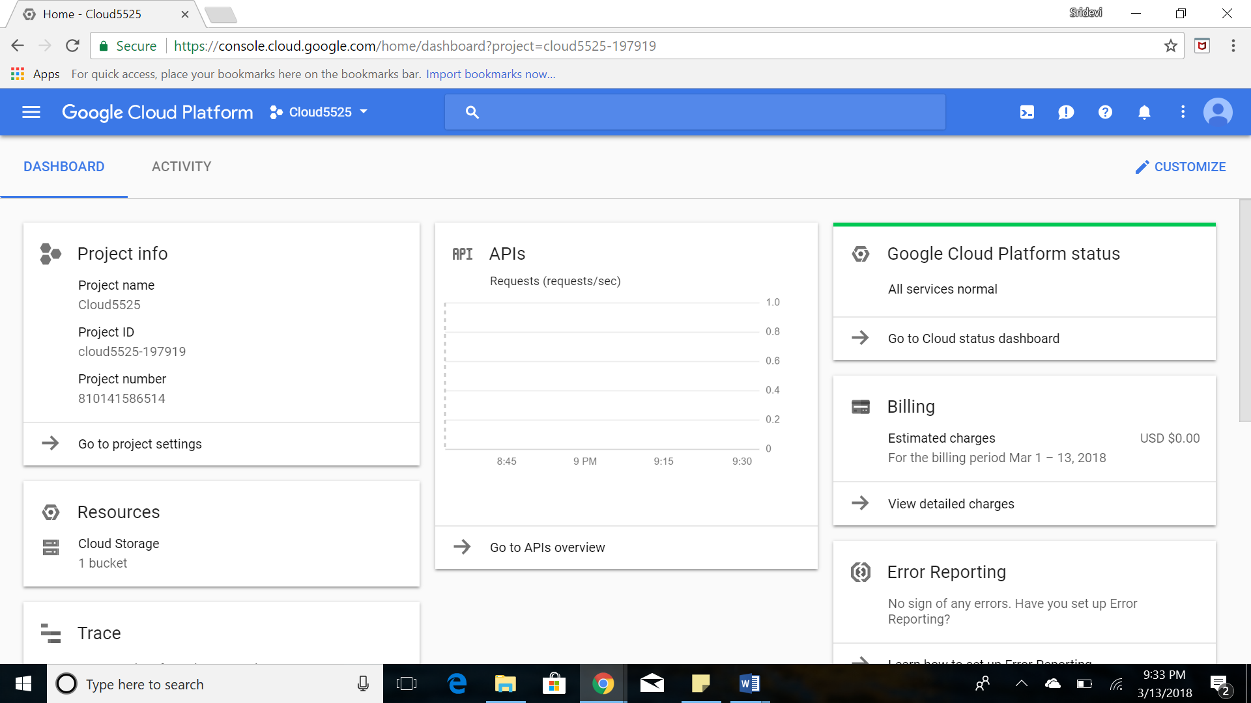

1. Create a new project in the cloud

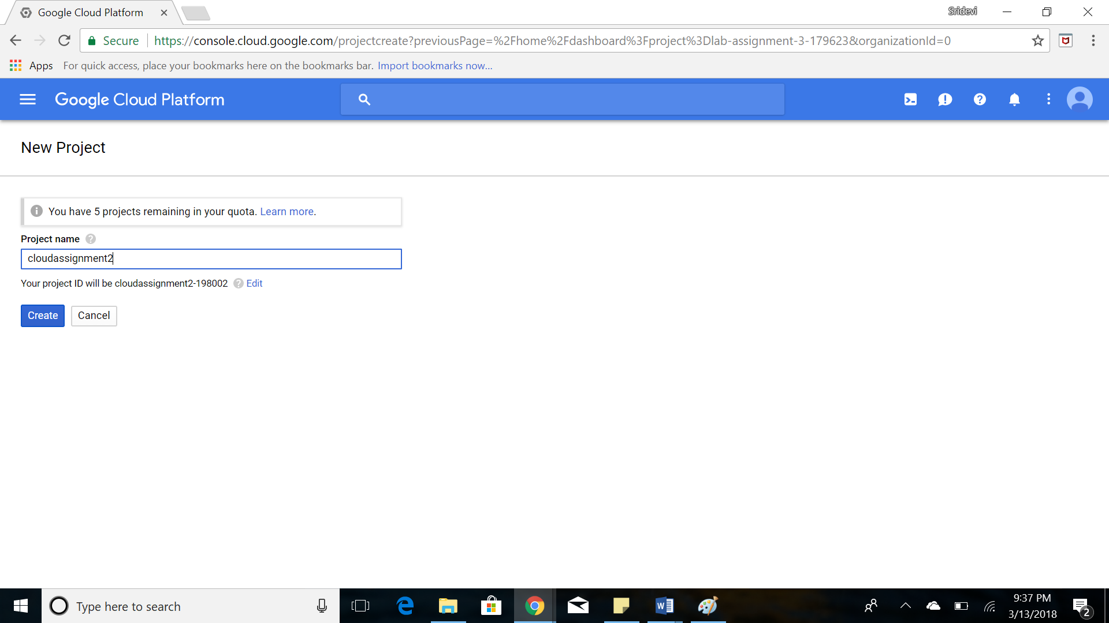

1. Create a new bucket under the storage section

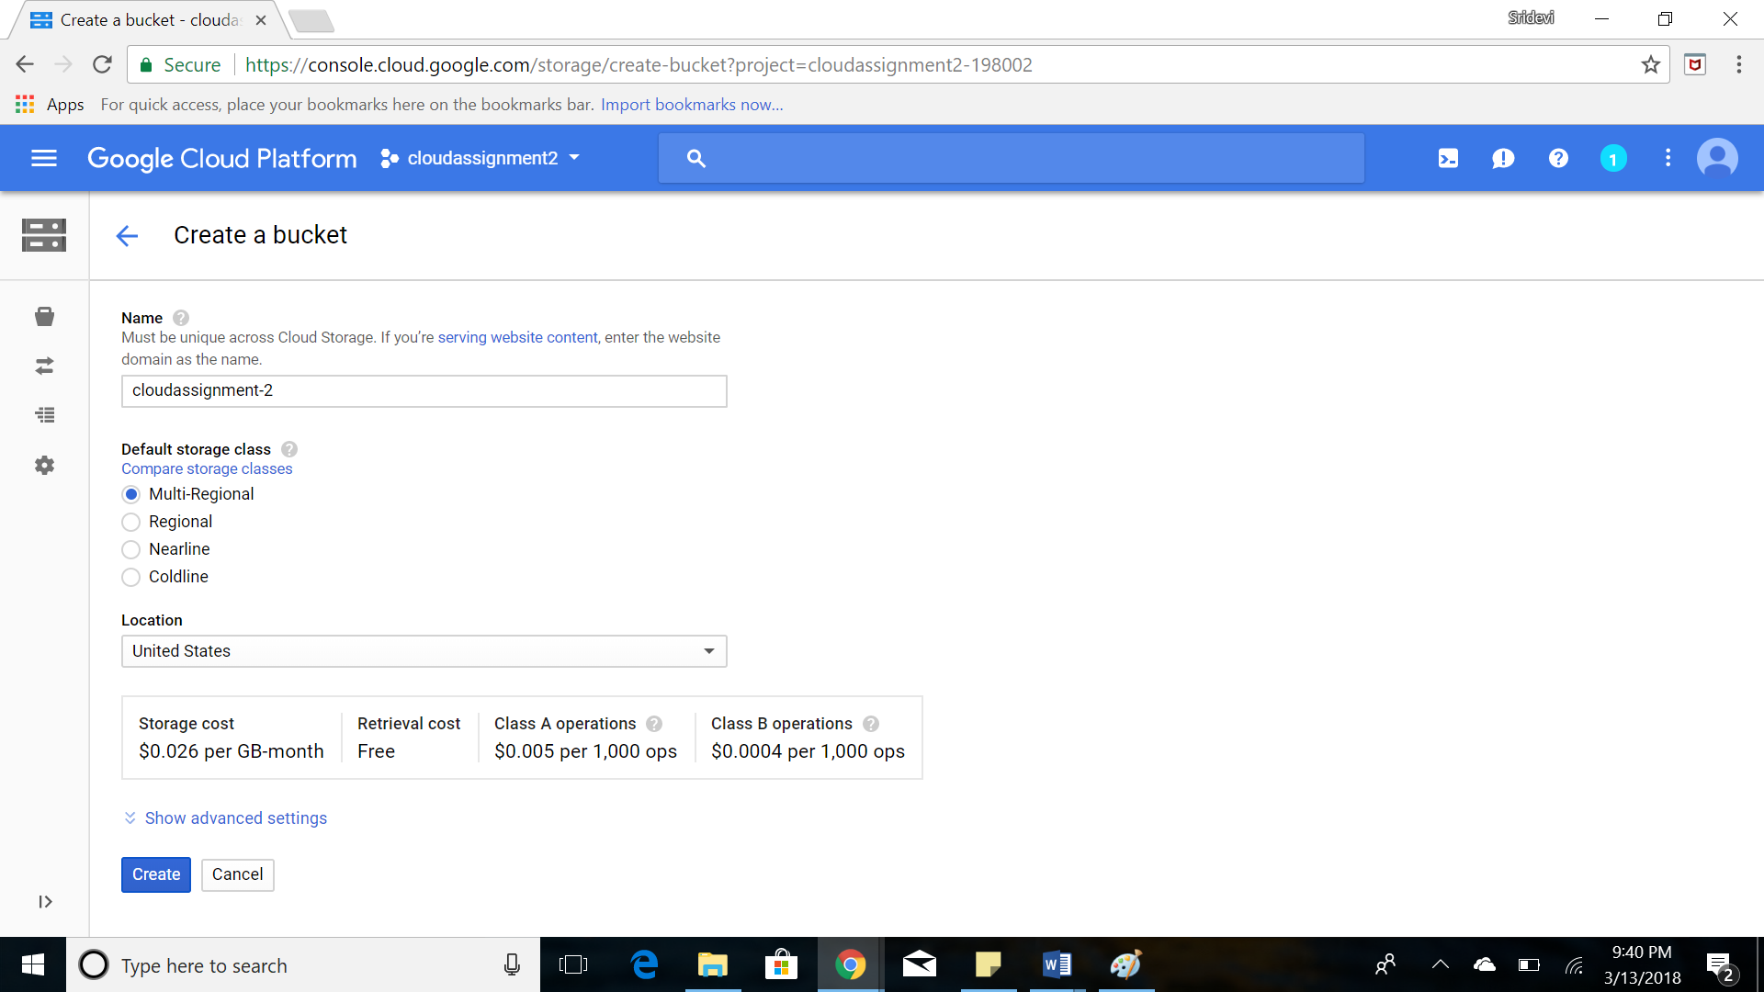

1. Upload the html file into the bucket

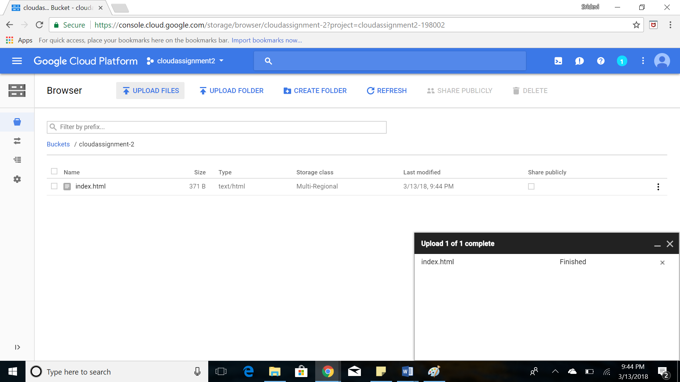

1. This creates a publicly shareable link for the html file and gives the required output

Link: <https://storage.googleapis.com/cloudassignment-2/index.html>

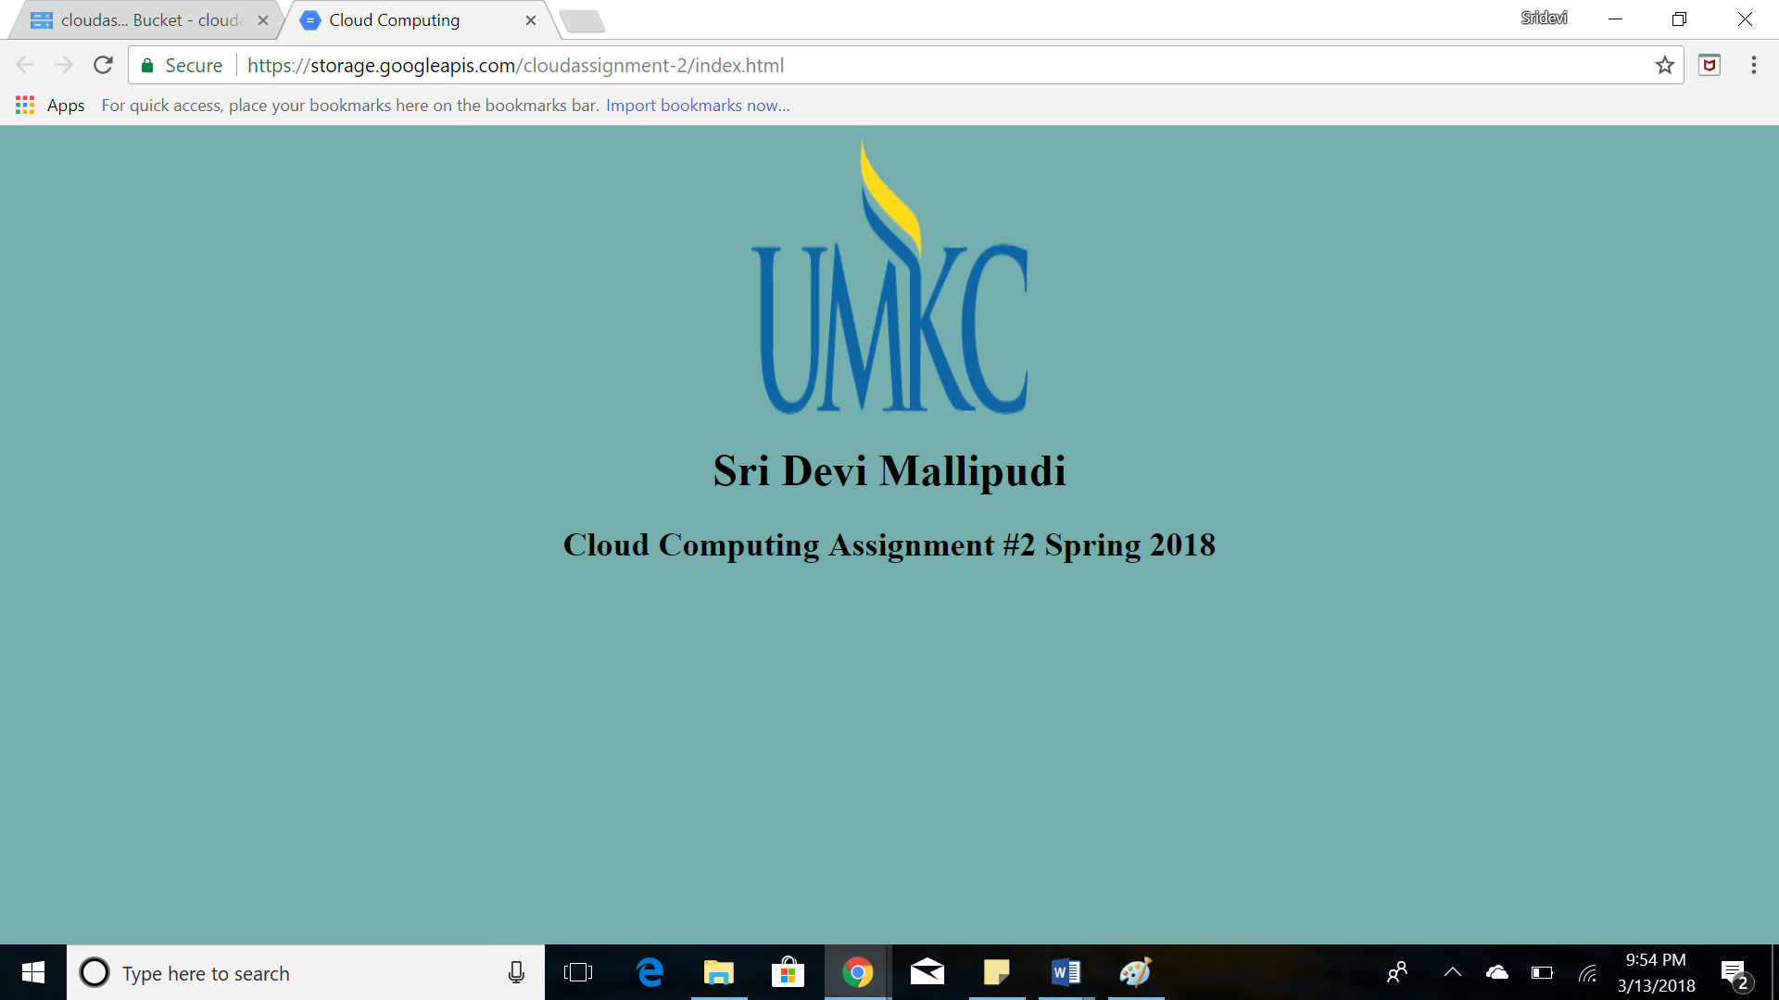

**Deploying the web page on Microsoft Azure:**

1. Go to URL <https://azure.microsoft.com/en-us/?cdn=disable> and login with your Microsoft credentials

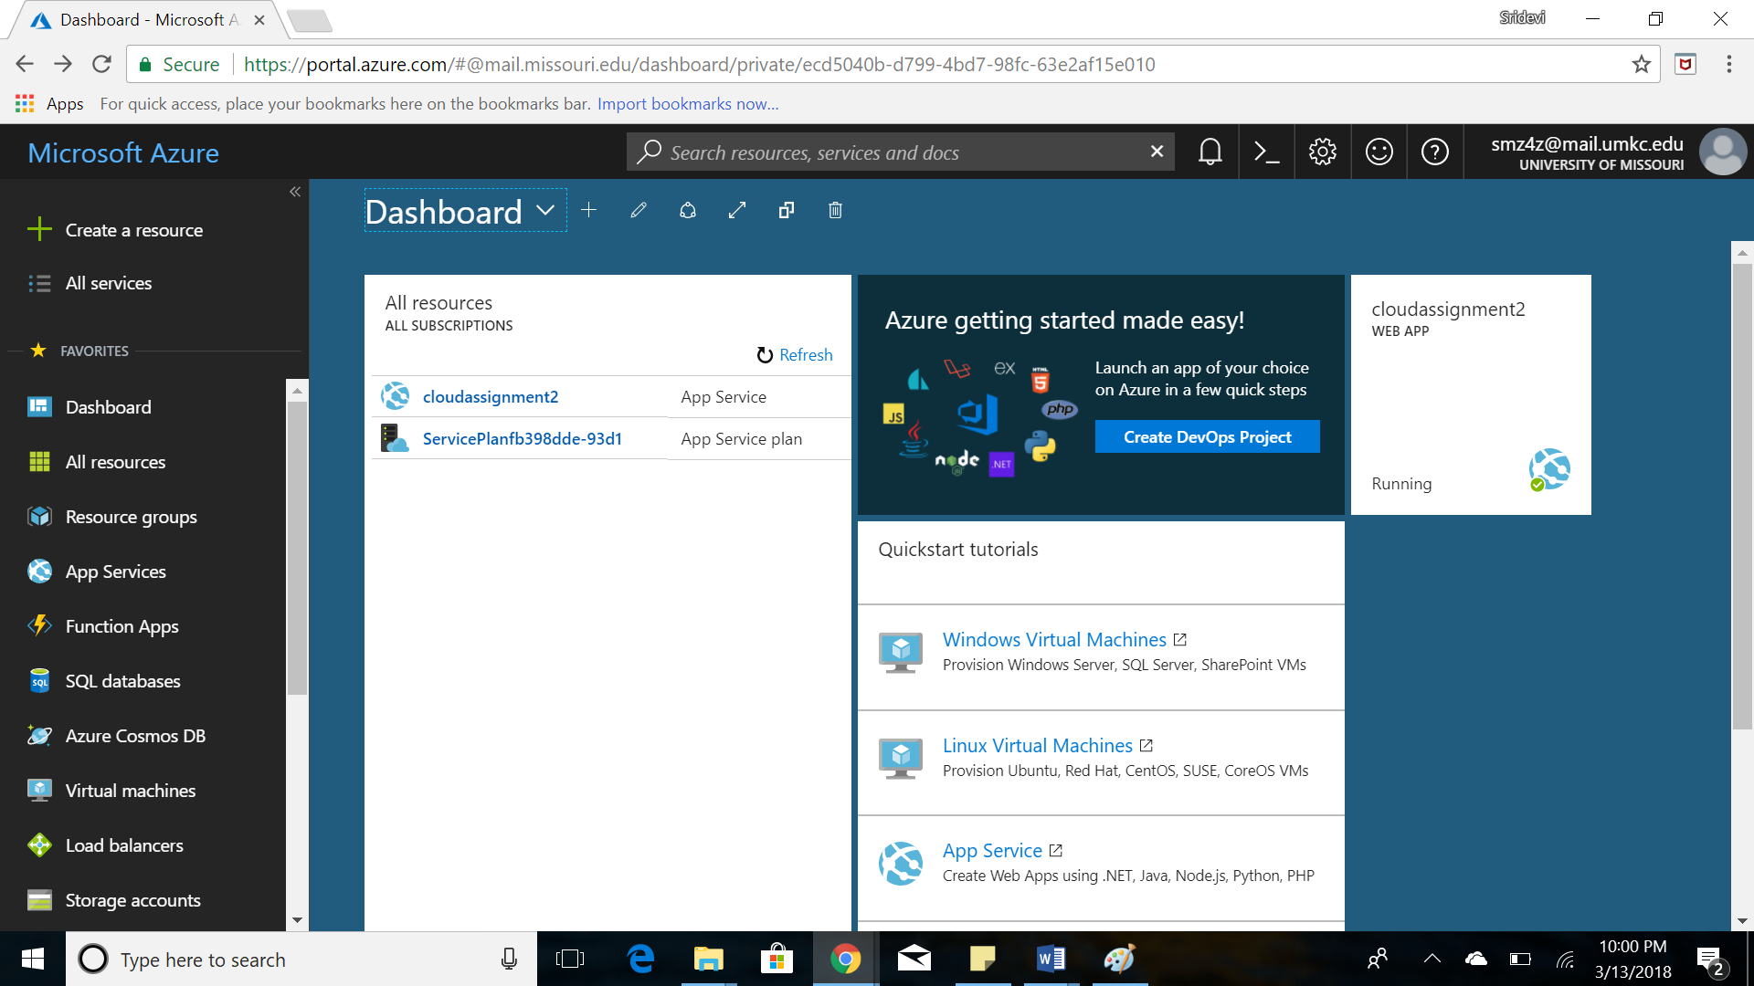

1. Create a new web App

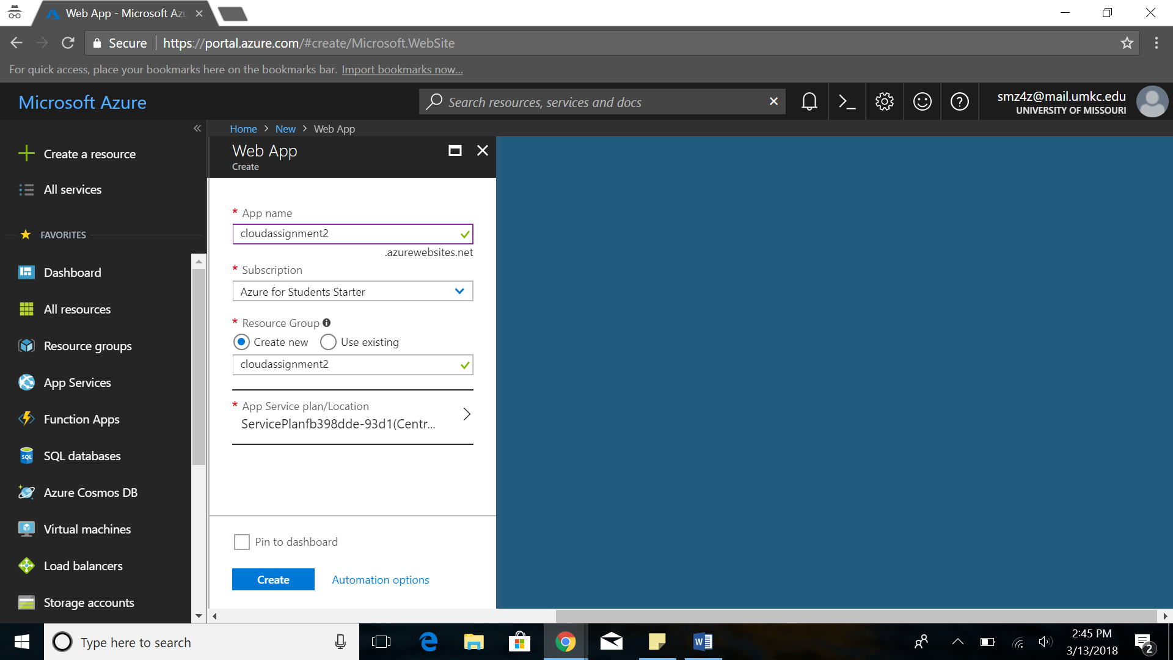

1. Under deployment options, choose OneDrive and configure your OneDrive account by providing account credentials.

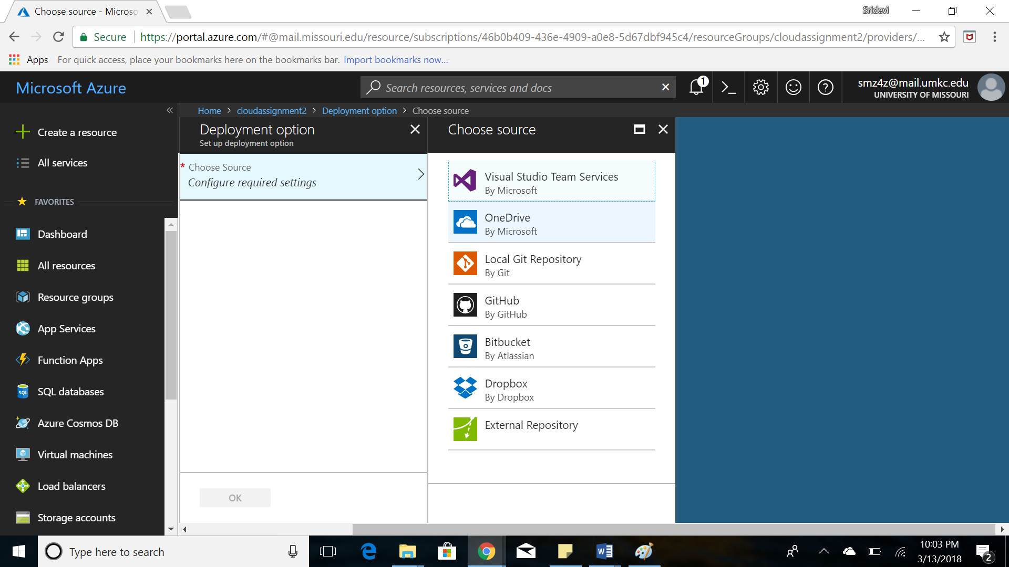

1. A new folder with the app name is created in OneDrive folder on your PC. Copy the index file into the web app folder and synchronize the web app

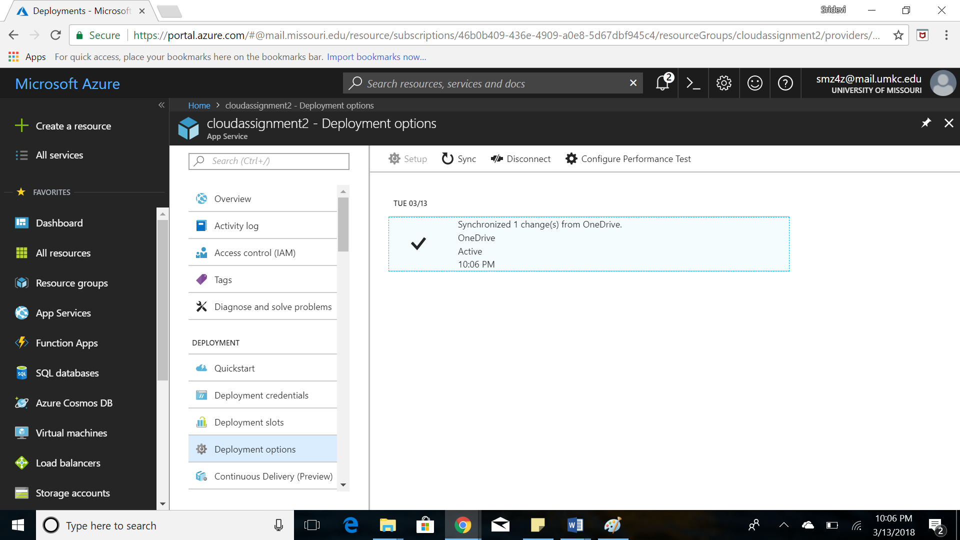

1. This creates a public URL for the app and by browsing, we get the required output

**Link:** <https://cloudassignment2.azurewebsites.net/>

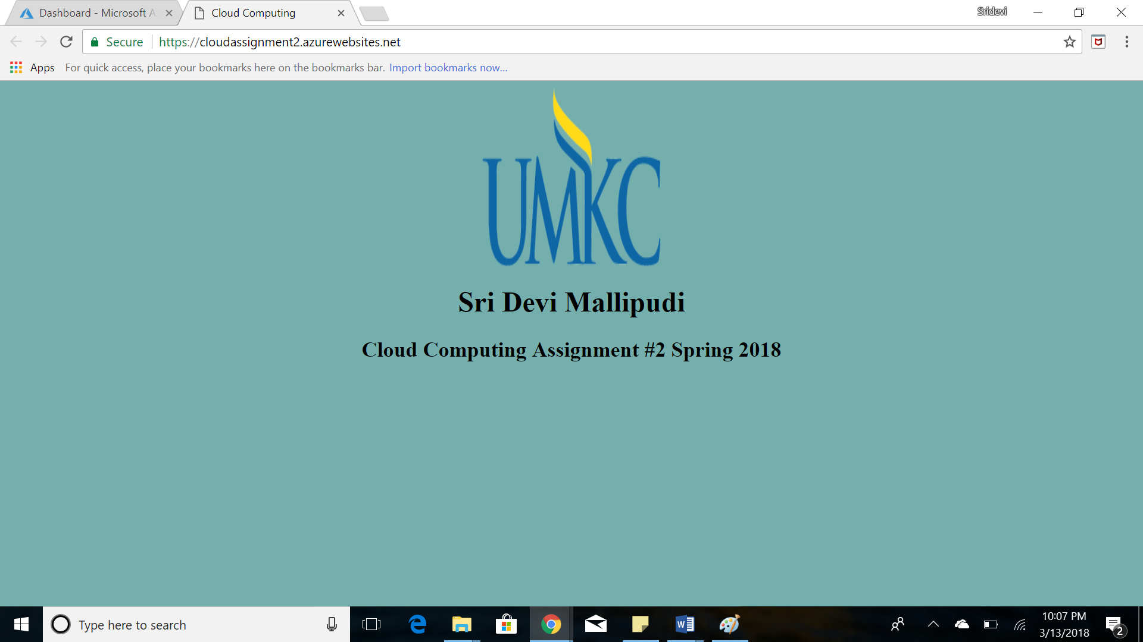

**Deploying web page on Amazon AWS:**

1. Go to URL <https://aws.amazon.com/ec2/?nc2=h_m1> and login with your amazon aws credentials

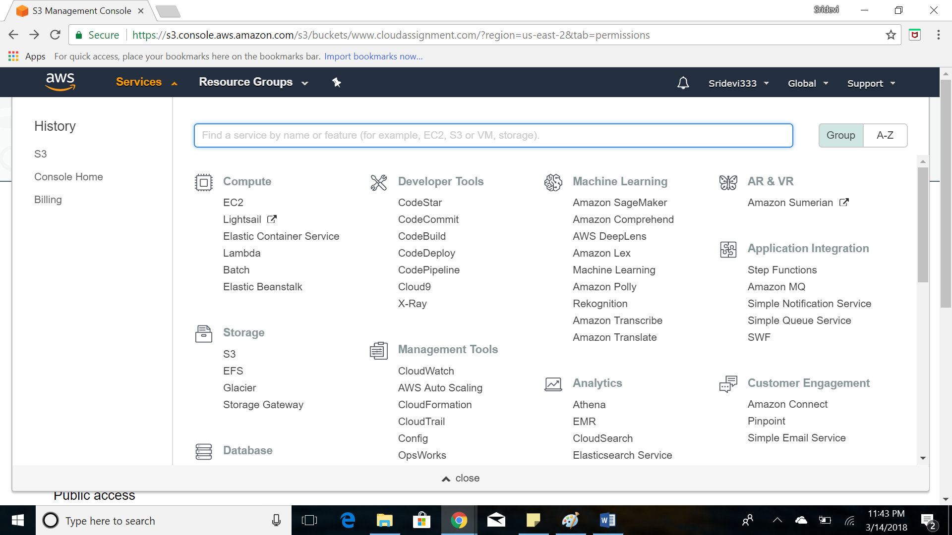

1. Under the services select S3 and create a bucket

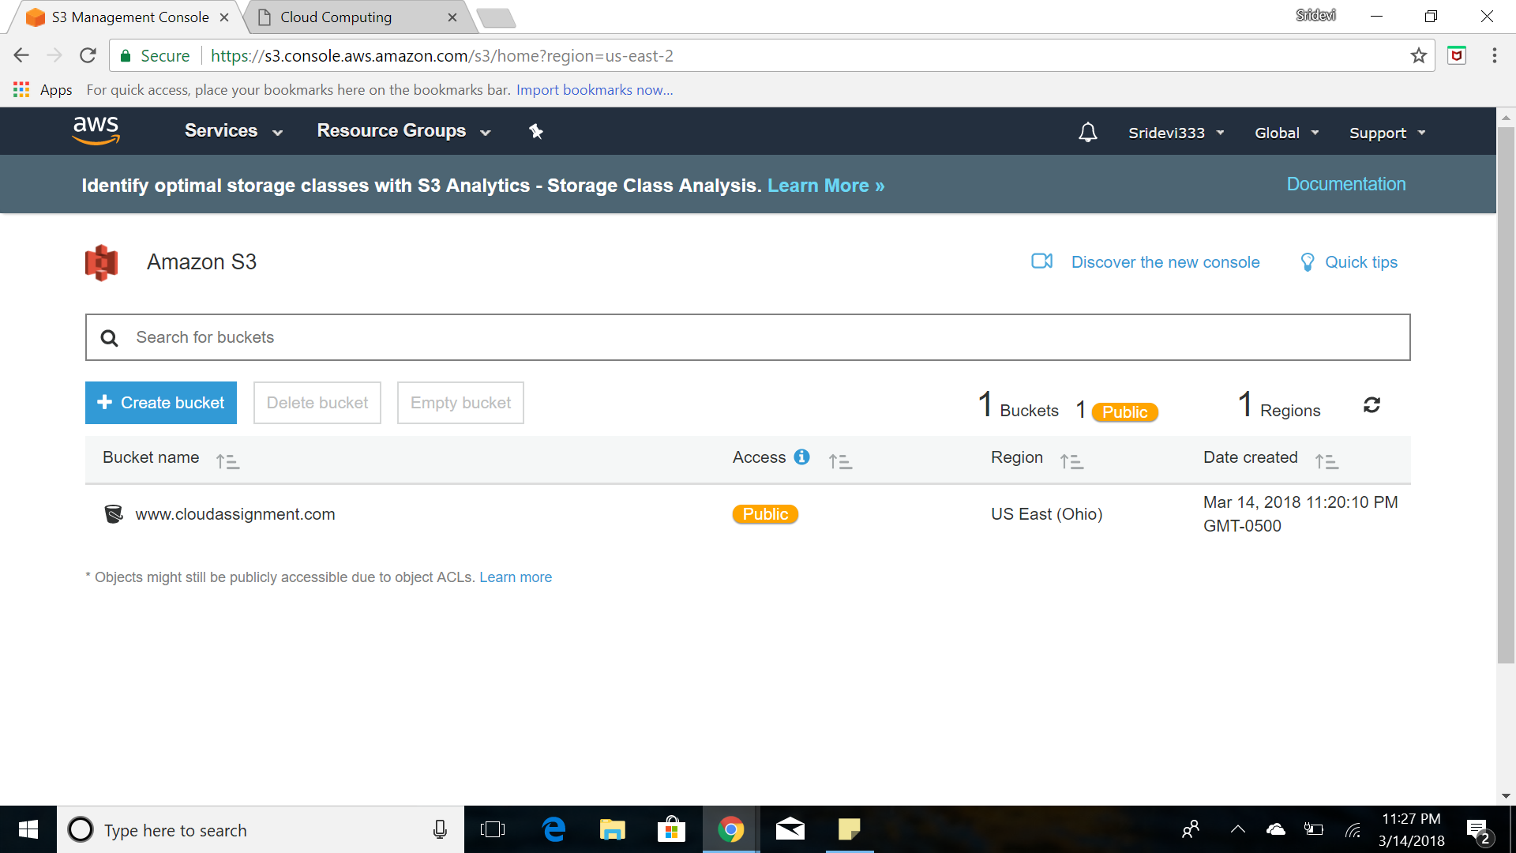

1. Upload the html file into the bucket

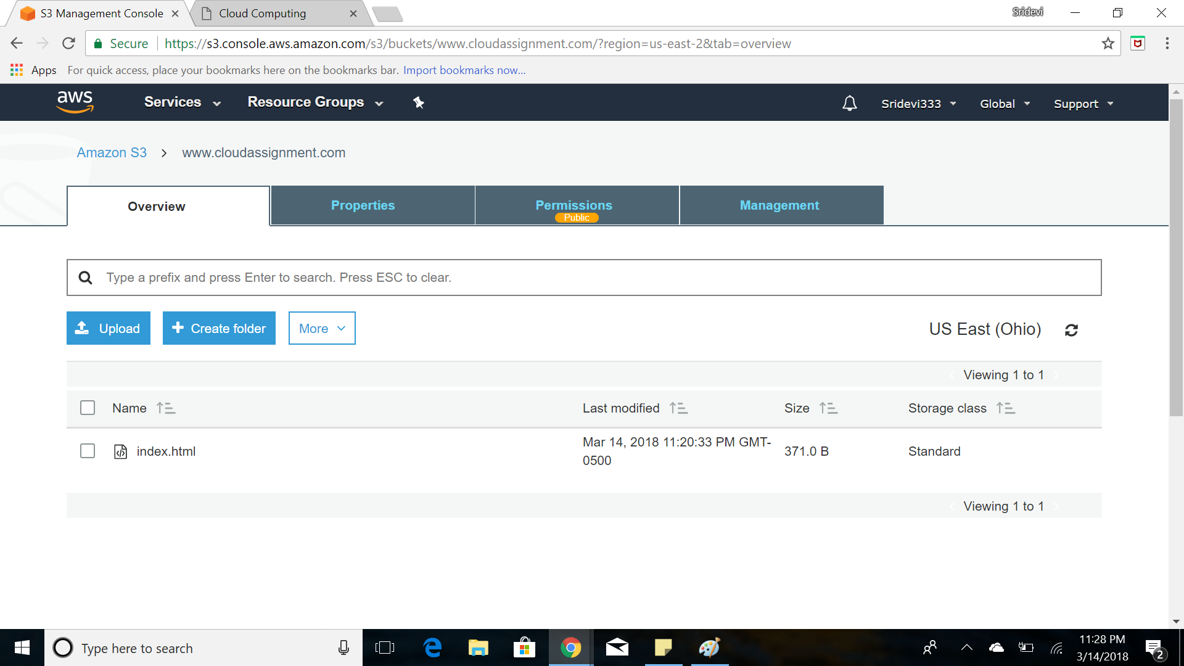

1. Under static website hosting set the index of the website and get the publicly sharable link

Link: <http://www.cloudassignment.com.s3-website.us-east-2.amazonaws.com/>

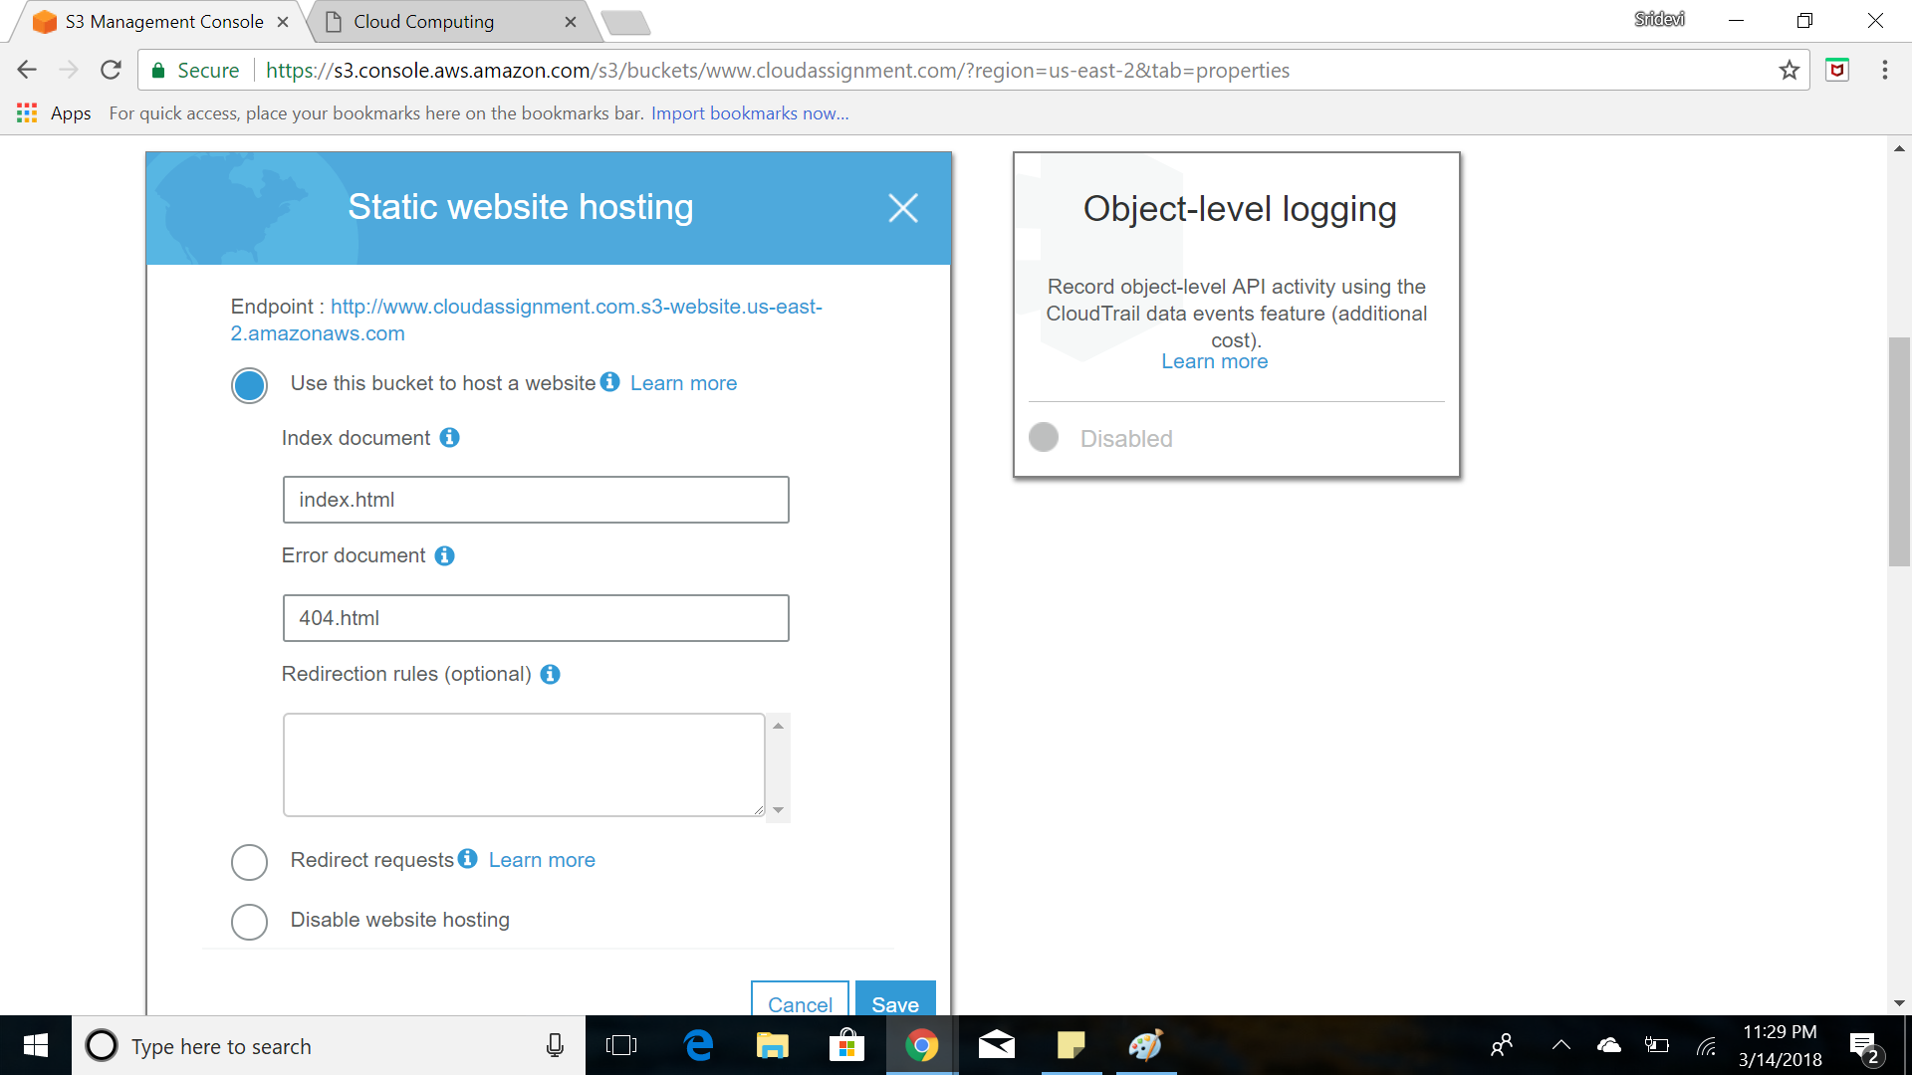

**EPILOGUE**

1) I got to know and exposed to various cloud platforms which is a whole new concept to me

2) The fun part of the assignment is the opportunity to learn the new concepts which is now boom in the current software industry and there is no such thing as difficult. The assignment went with such an ease that it is challenging passing through each step

3) GENI: Used already, got along very easily

4) Amazon AWS: Professional

5) Google Cloud Platform: Used to Google, so got along

6) Microsoft Azure: User friendly UI

7) I enjoyed working with Microsoft Azure the most